**School name: University of Greenwich**



**ASSIGNMENT TITLE**

**COMP1640**

**Course Name:** Enterprise Web Software Development – COMP1787

**Student Name:** Ngo Tien Phat

**Student ID:** GCS200429

**Tutor name:** Phan Minh Tam

**Submission Date:** 25th April 2024

**Introduction**

This is a report on web application development, product development, self-evaluation, and teamwork evaluation. Based on the lesson requirements, we design a web application with capabilities such as collecting user comments, users can also submit comments for each concept, loves and dislikes. The SCRUM development process is being used in this project.

SCRUM is a software development approach that demonstrates how a team may efficiently collaborate to generate a software product. The primary premise is to break down the program into tiny sections for development (these portions must be read and distributed), collect user feedback, and make changes based on the input. This will guarantee that the final product satisfies the expectations of the consumer.

SCRUM is built on the nature of the developer; thus, it is simple to comprehend and use, resulting in high interaction among the programmers on the team and the creation of good products. Rather than being imposed from without.

|  |  |  |
| --- | --- | --- |
| **Role** | **Email** | **Password** |
| Admin | admin@gmail.com | 123 |
| Manager | manager@gmail.com | 123 |
| Coordinator IT | coordinator@gmail.com | 123 |
| Coordinator Business | coordinator1@gmail.com | 123 |
| Coordinator Graphic Design | Coordinator2@gmail.com | 123 |
| Coordinator Doctor | Coordinator3@gmail.com | 123 |
| Coordinator Music | Coordinator4@gmail.com | 123 |
| Student IT | lykimanh@gmail.com | 123 |
| Student Business | tranthingochong@gmail.com | 123 |
| Student Graphic Design | doanhdoanh@gmail.com | 123 |
| Student Doctor | luclongquan@gmail.com | 123 |
| Student Music | tungne@gmail.com | 123 |
| Guest | guest@gmail.com | 123 |

**Evaluation**

Working together, our team produced a web application that meets all of the criteria. I may rate the product as follows:

* 95% for the template
* 80-90% of the functions
* Efficiency: 95%
* In terms of time: 100%

**Product**

You come to the first step when implementing features available on the web. Sign up and Log in for an account in advance to be able to log in to our main website.

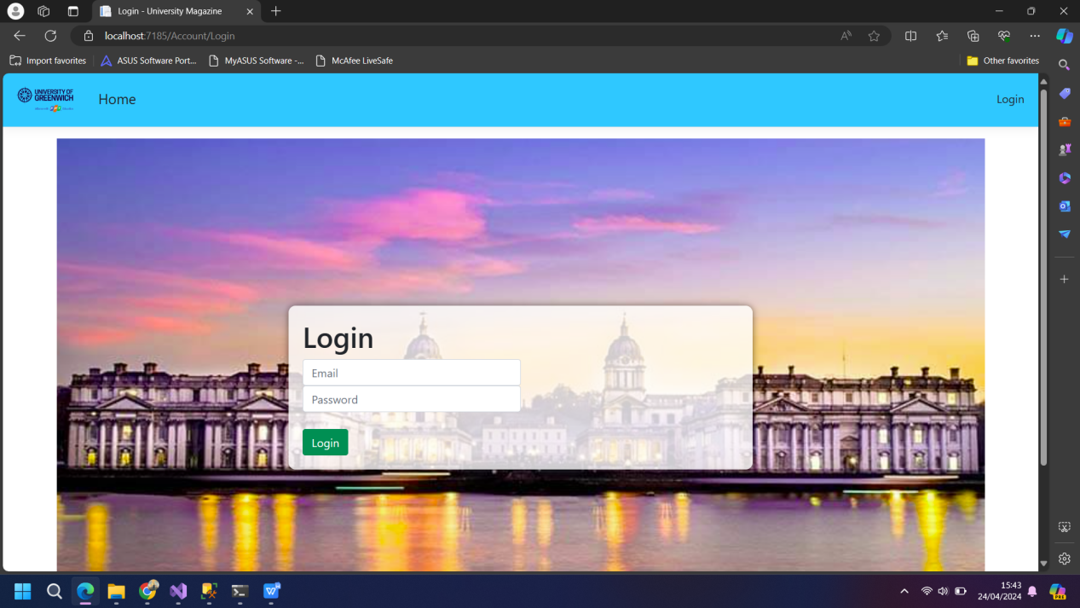

After logging in to your account, proceed to our main page, and please experience it



This is the homepage of our website before or after logging in.

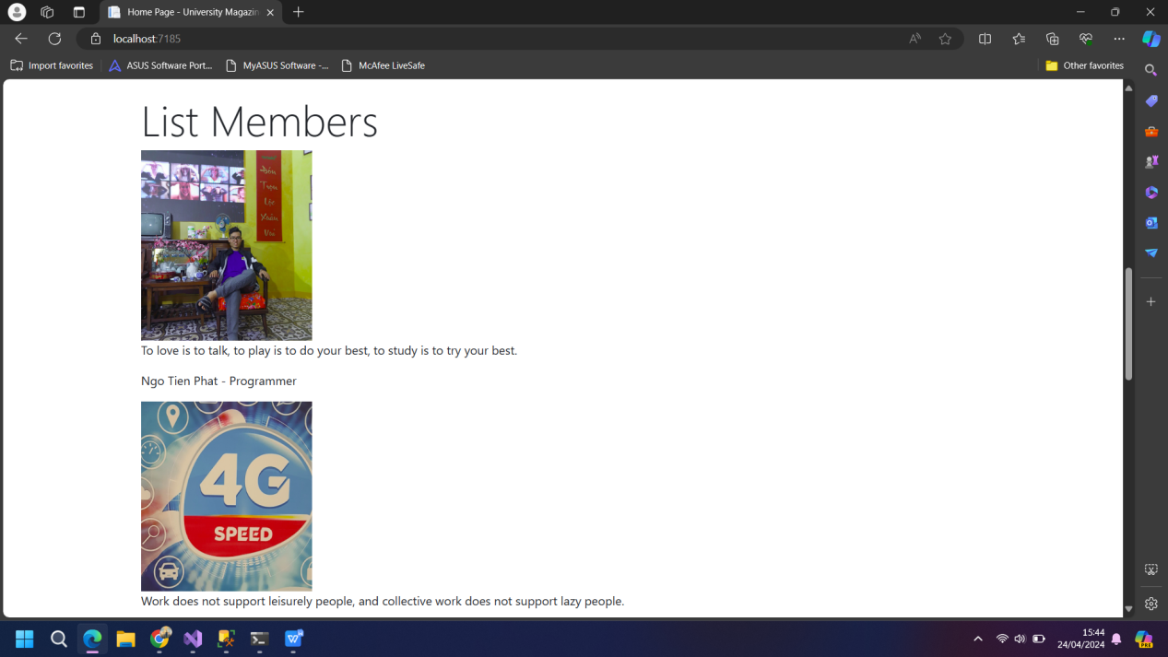

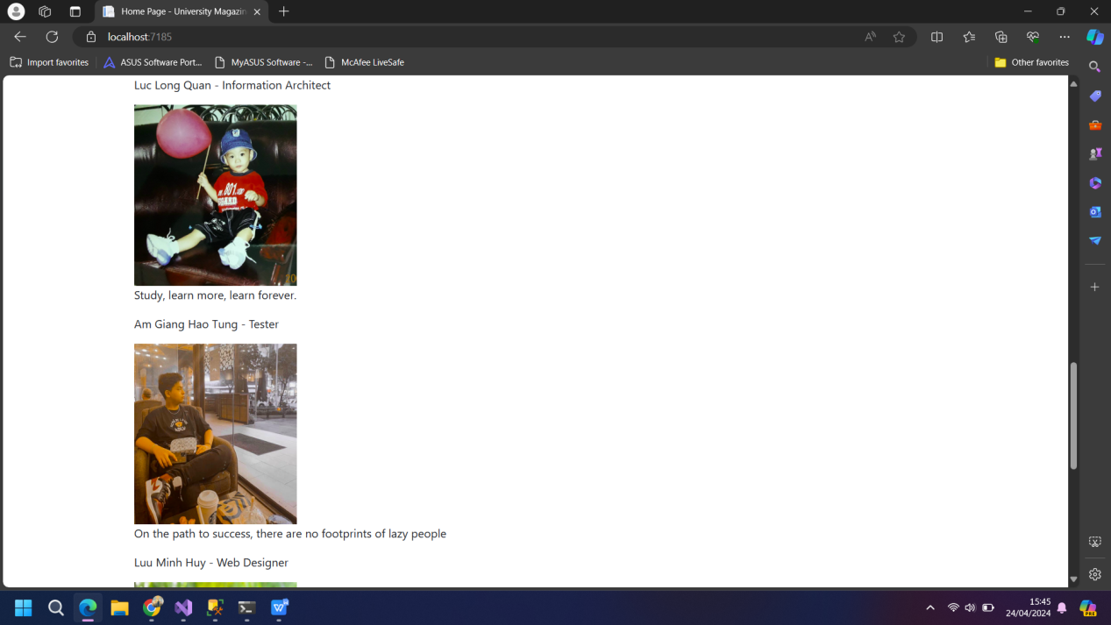

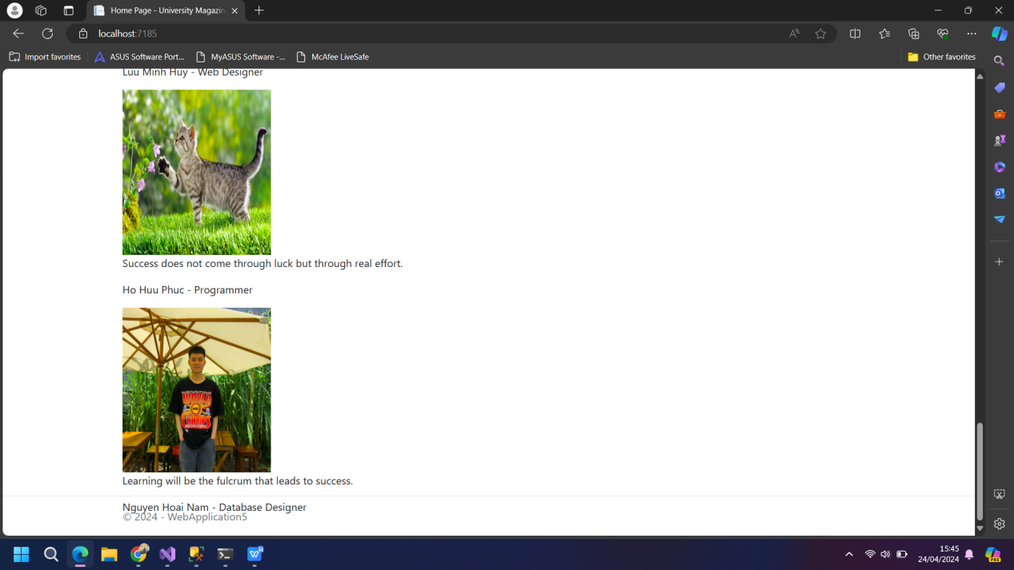

And here is a list of our team members along with their roles and job duties when starting to design the website. There are a total of 6 people in 1 group



The main page of the Administrator, on the layout bar, will have the Home page, Faculty, List Users and List Feedback. In the Management section there will be full functions such as Faculty, Roles and Users. But the Admin main page will not have Statistics function



In the Manager page, the items include View And Download Contributions and Statistics. They can view details of students' papers but cannot edit and delete any papers and they can download them in a ZIP file for viewing. In addition, they can view statistics of each article belonging to different Faculties.



The Student page has only two buttons: Home and Student submission. Students from the Faculties will submit papers with one or more contributions of their choice.



This is the Coordinator page that will be in charge of Faculty IT, there will be other Coordinator pages that will be in charge of Faculties such as Business, Graphic Design, Doctor or Music. I created 5 Coordinator pages with different Faculties to view student Contributions for each logged in Faculty.

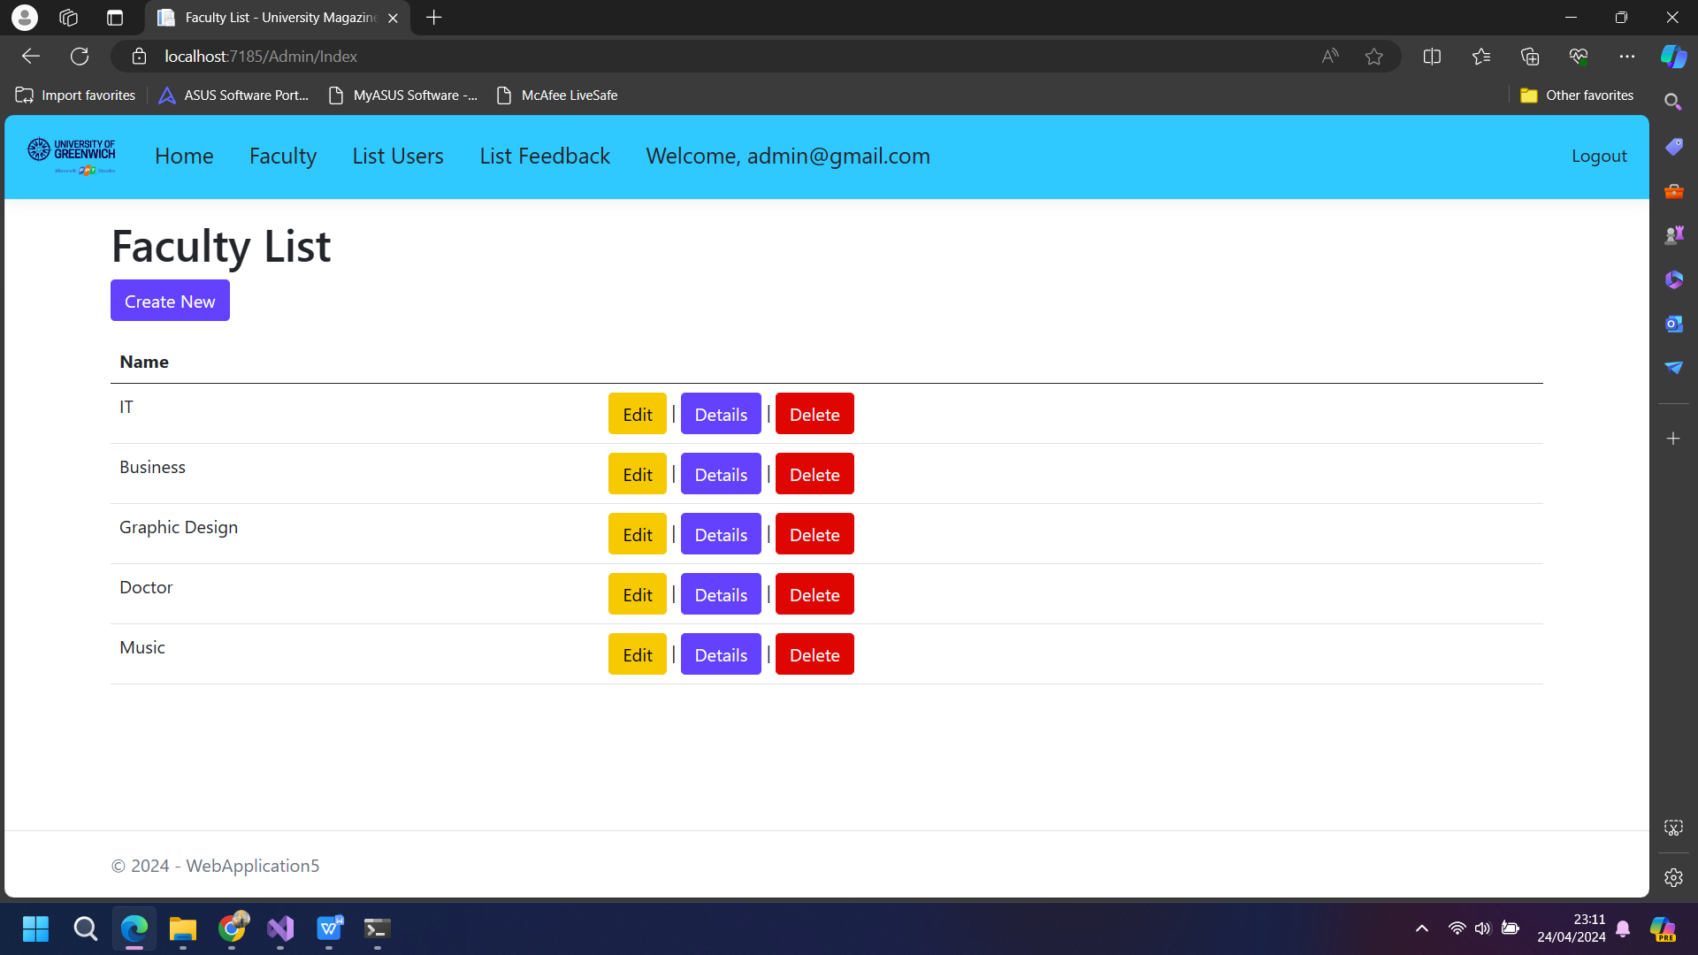

This is the Faculty page in Admin, this page will add, edit, delete, read with 4 different color buttons.

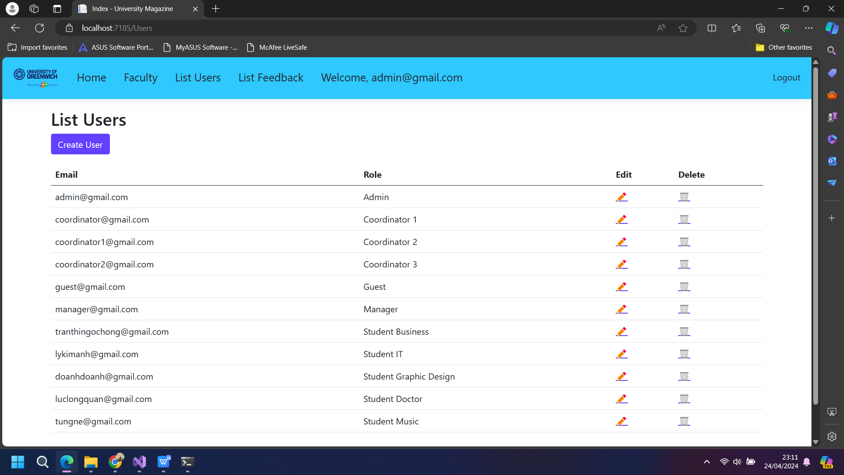On this page, we will be able to view accounts with different emails and Roles for each account. In addition, each account can also Delete account if not in use or not needed.

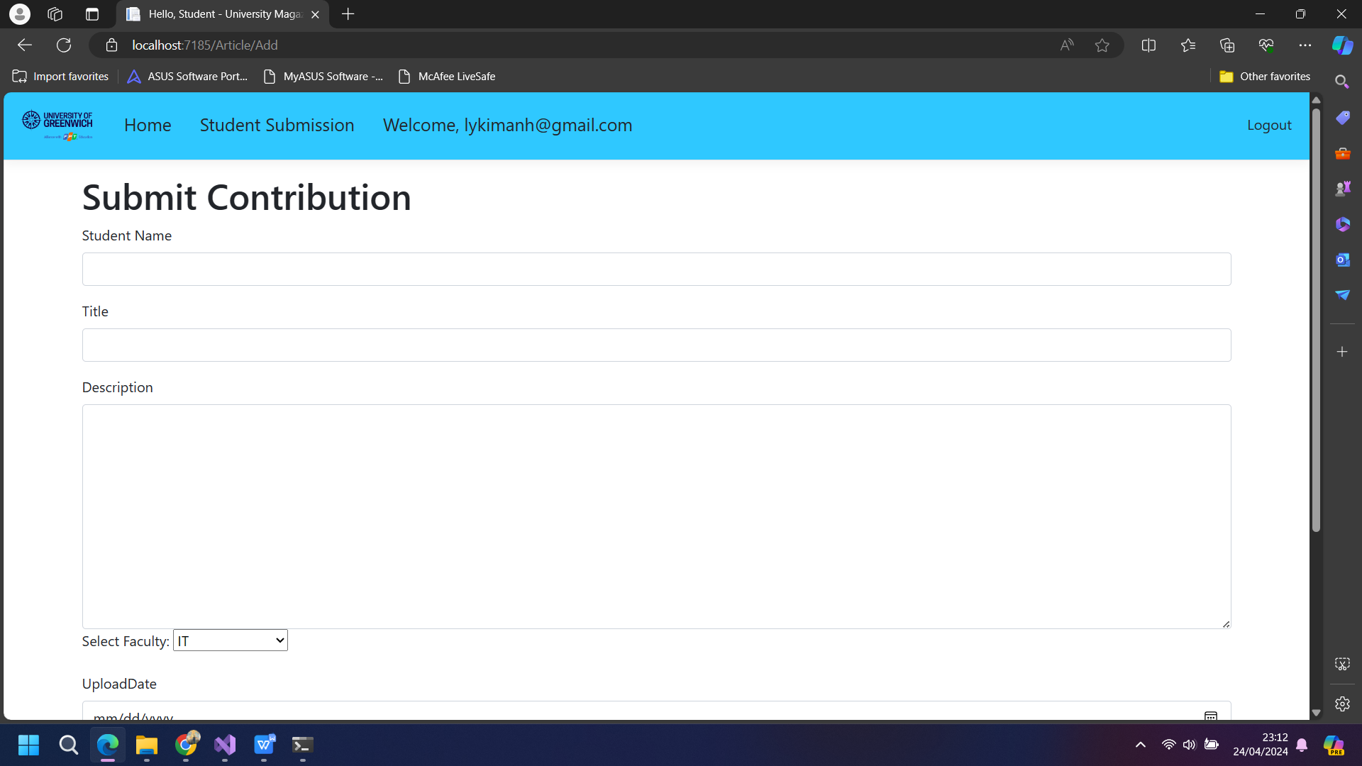On this page, students of each Faculty can contribute articles that students have uploaded to the page. Images can be included as evidence of their contributions to this article.

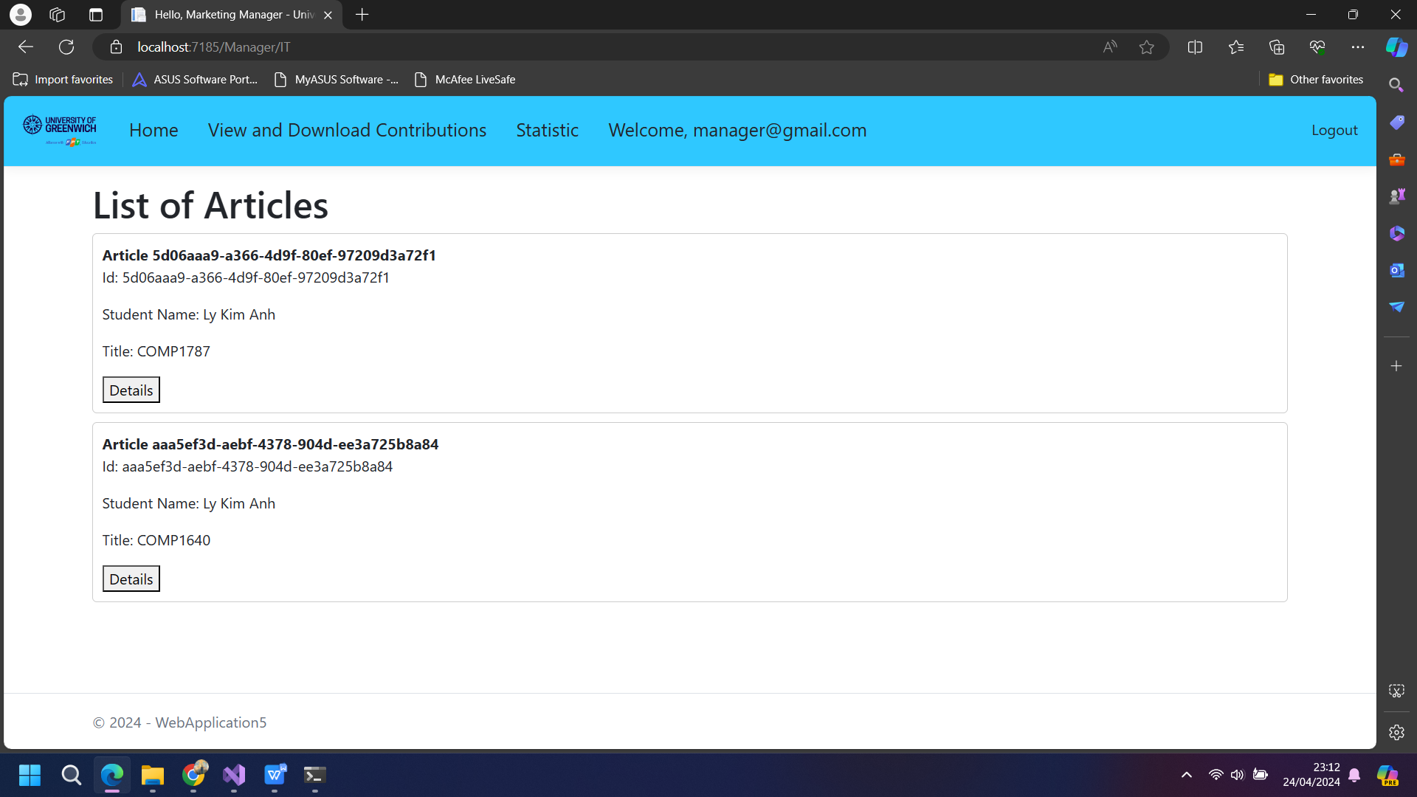

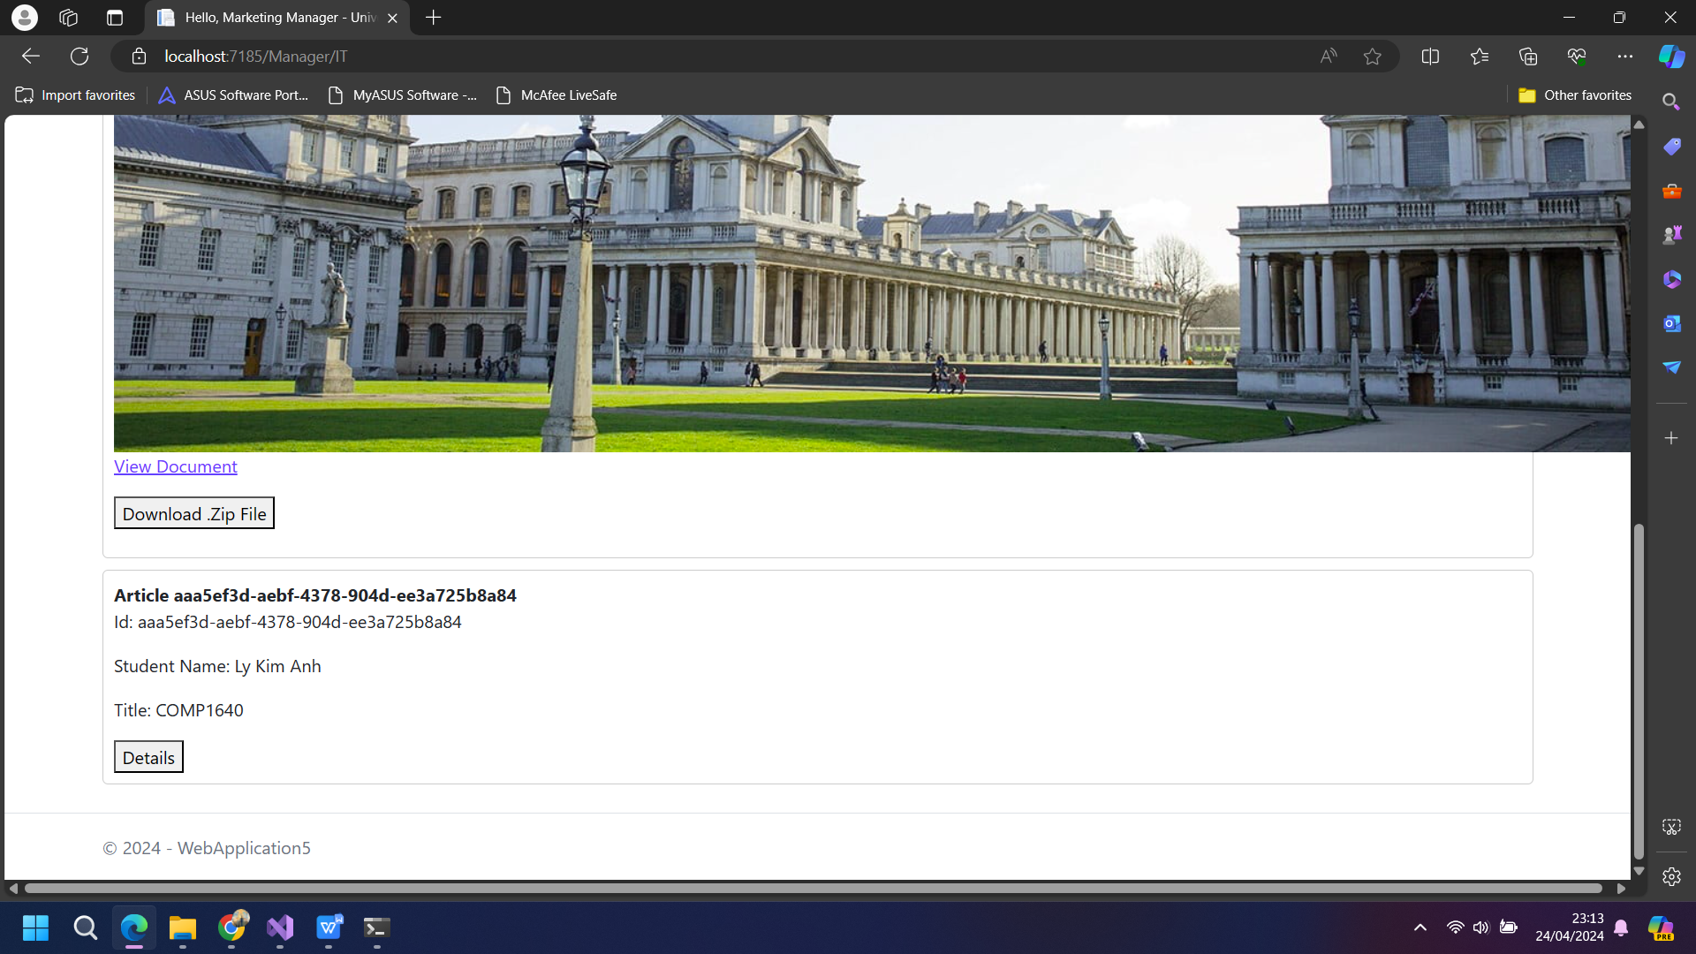

On the two pages above, Manager will only be able to view detailed student contribution information. In addition, they will also be able to download in ZIP files to view those articles.

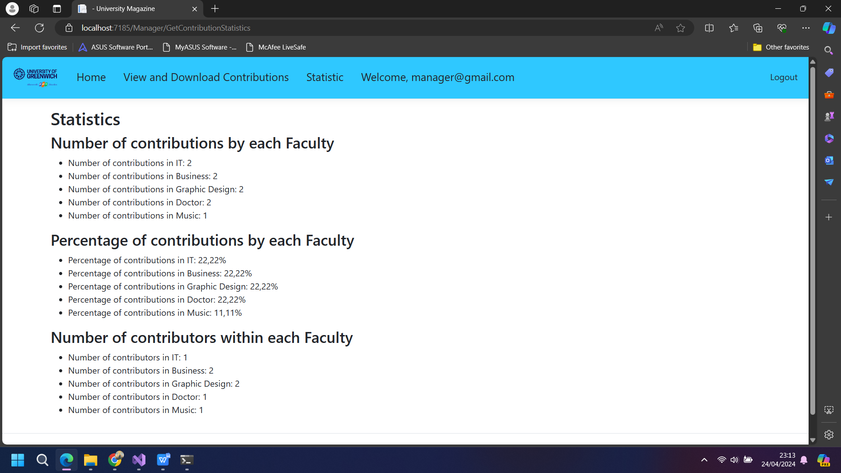On this page, Manager can also check the number of contributing students of each Faculty. Includes figures, percentages and within each Faculty.

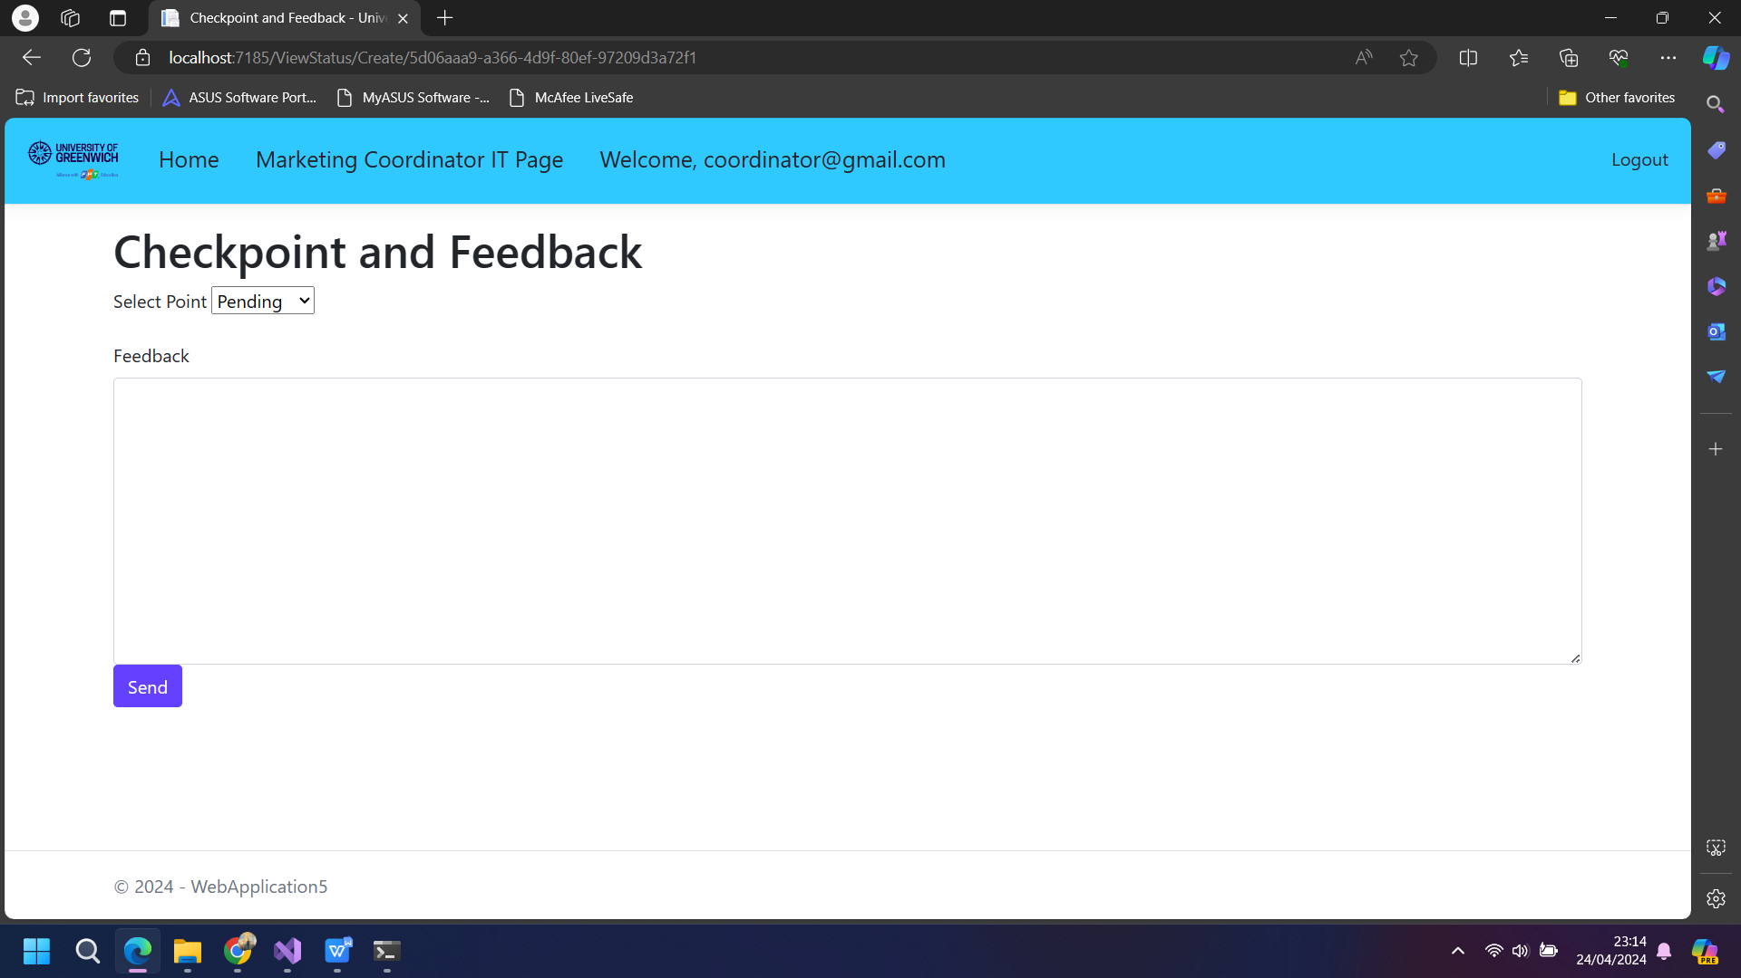

In this website, the coordinator will have the ability to "approved" or "rejected" articles that students have contributed. The Coordinator can also make his or her own comments.

My team created an online role-based application with on-demand functionalities. The system has three built-in roles:

|  |  |  |  |
| --- | --- | --- | --- |
| Admin | Manager | Student | Coordinator |
| * System maintenance. * Add and Delete users. * See feedbacks * Sign in, log out. | * Add, edit, and remove tags. * Statistical reports. * Download the ZIP file. * Sign in, log out. | * More ideas. * Add comment. * See status and comments. * Sign in, log out. | * Add status and comment * See ideas from students * Sign in, log out |

Our website is designed for ease of use, it is also available on devices such as Phone, tablet, laptop. The navigation part of the application is designed to be simple, easy to see, and reasonable for users to interact and experience. The buttons are also designed with a different, minimalist style, large enough for users to press even though they are a bit not very beautiful. The text style and text size we use are common, minimalist, easy to use, reasonable, titles are larger than other texts and users can easily find and get information. The background color is harmonious, easy to see, do not use too many bright or dark colors, and have a reasonable layout







In the pictures above is a website suitable for all electronic devices such as phones, tablets or laptops,... I used the Check The Responsive feature to test this interface.

**Process**

|  |  |  |
| --- | --- | --- |
| **COLLECTING IDEAS MANAGEMENT SYSTEM** | | |
| **Group Members** | Ngo Tien Phat GCS200429 | Scrum Master, Product Owner, Backend Developer, Tester |
| Luc Long Quan | Information Architect, Frontend Developer, Web Designer |
| Am Giang Hao Tung | Information Architect, Tester |
| Luu Minh Huy | Frontend Developer, Web Designer |
| Ho Huu Phuc | Backend Developer, Tester |
| Nguyen Hoai Nam | Database Designer, Frontend Developer |
| **Teacher** | Phan Minh Tam | |

**Sprint backlog**

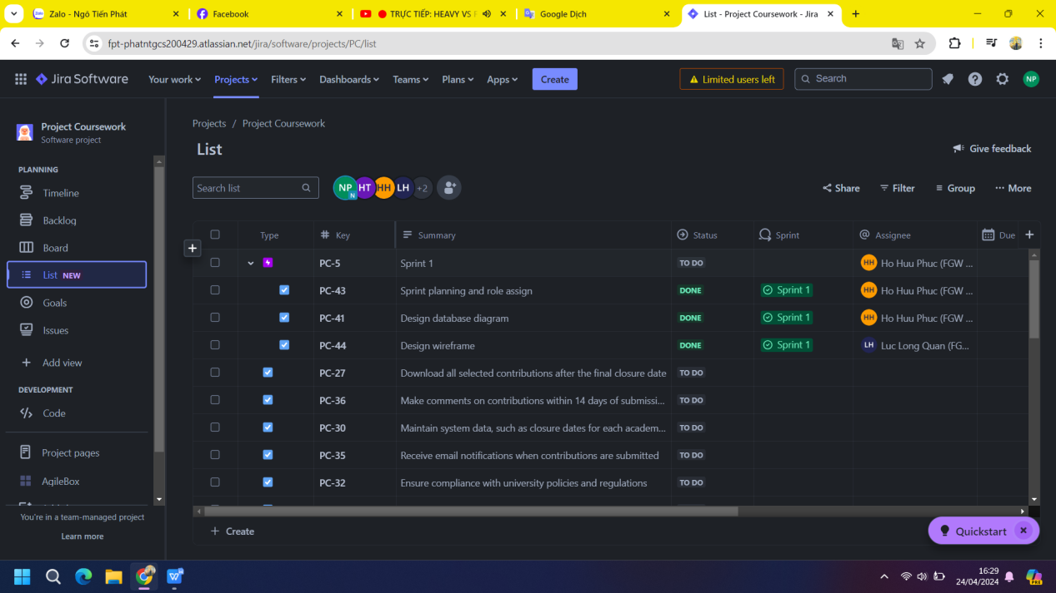

According to the tasks that have been set up in the sprint backlog, in order to complete each sprint on time, I have to arrange the tasks properly to complete the work in time.

**Product backlog**

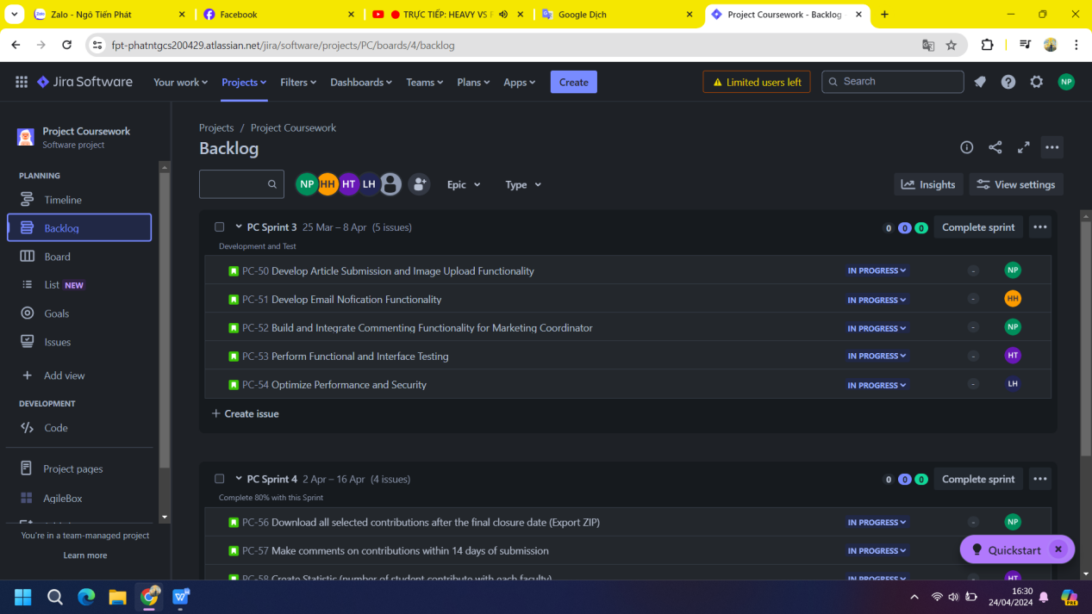

In this stage, I have to determine what is important, what is poor, what is done first, what is later, must be completed on time.

Meetings

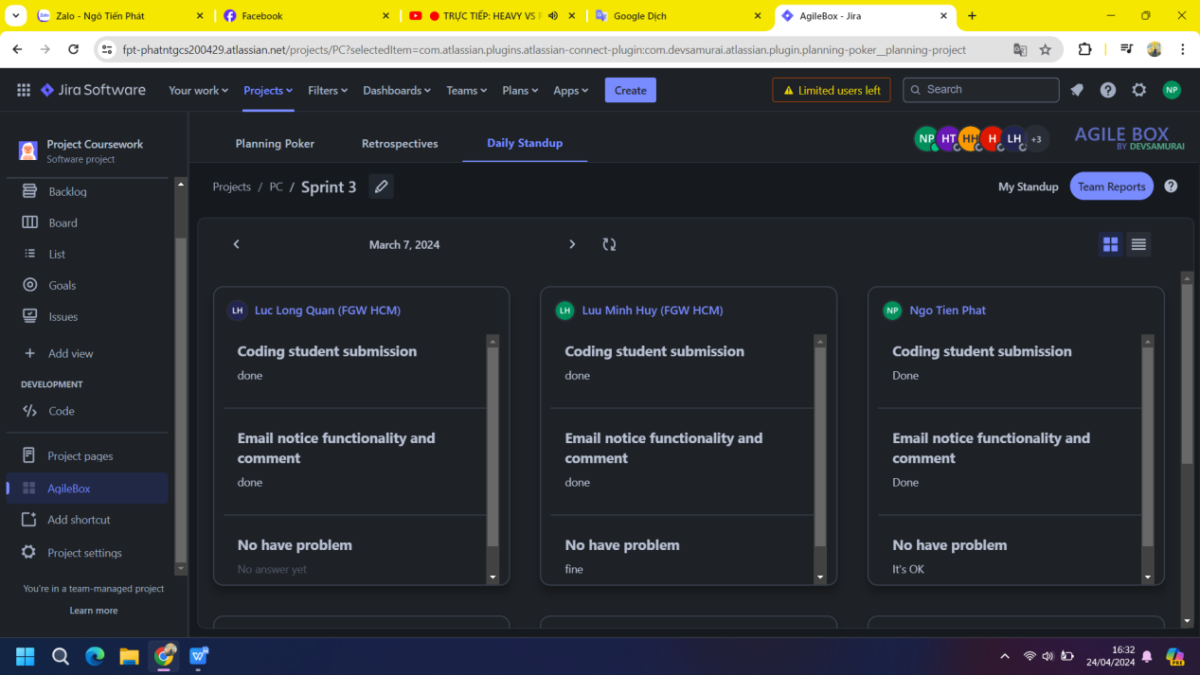

To accomplish my duties, I have to attend full team meetings to check the work of other members, come up with appropriate criteria for their work, and also check my work, to make sure that my work is on track.

Design:

Use case diagram

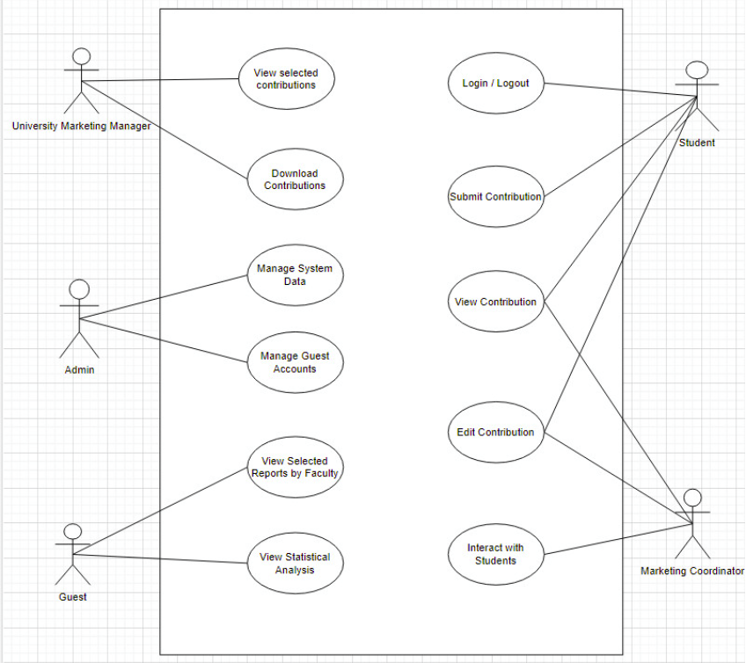

ERD

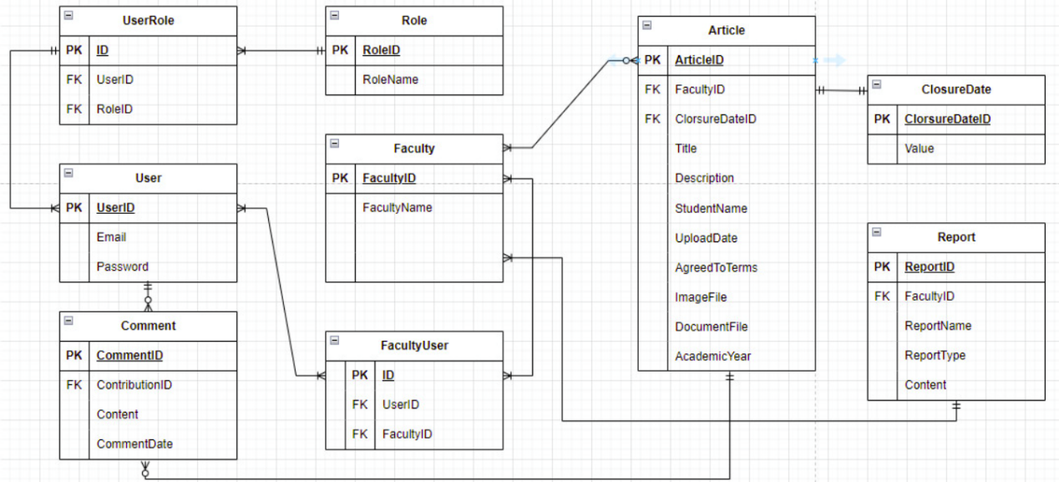

Sitemap

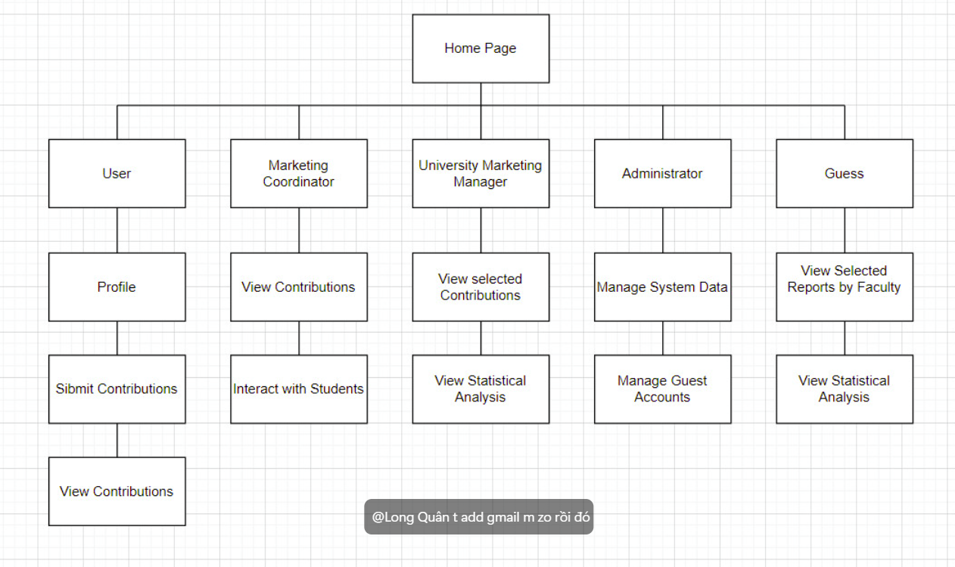

Wireframes

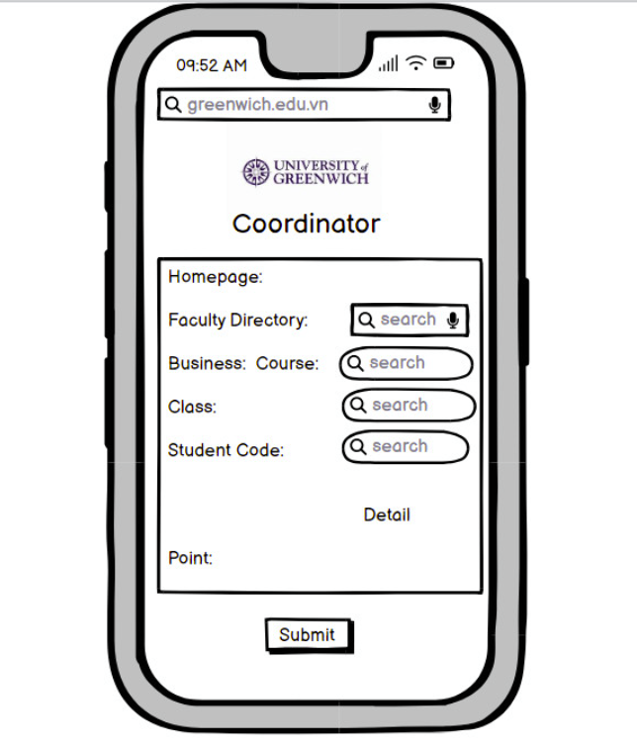

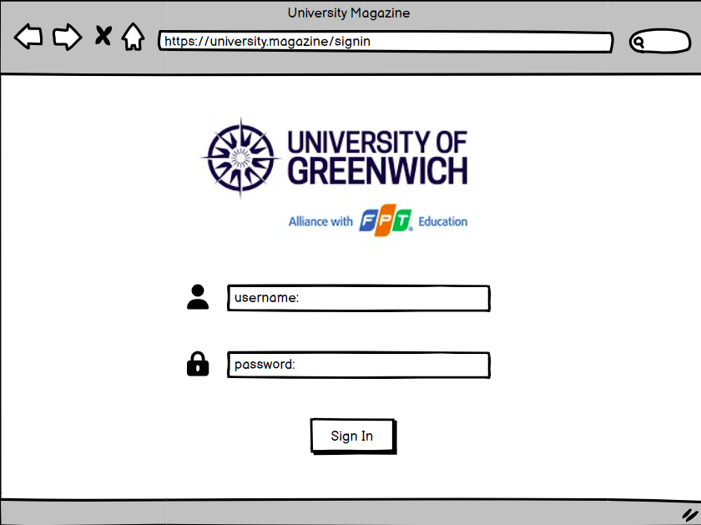

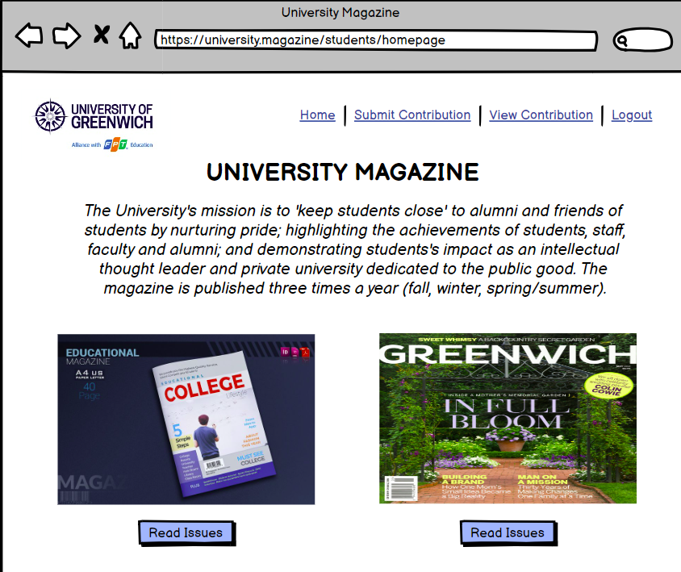

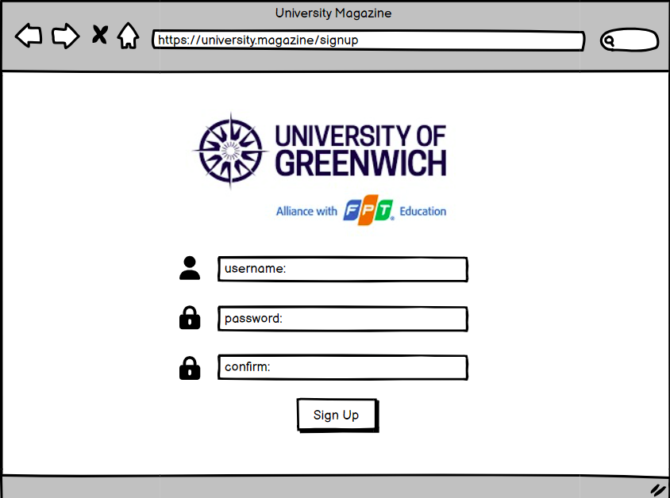

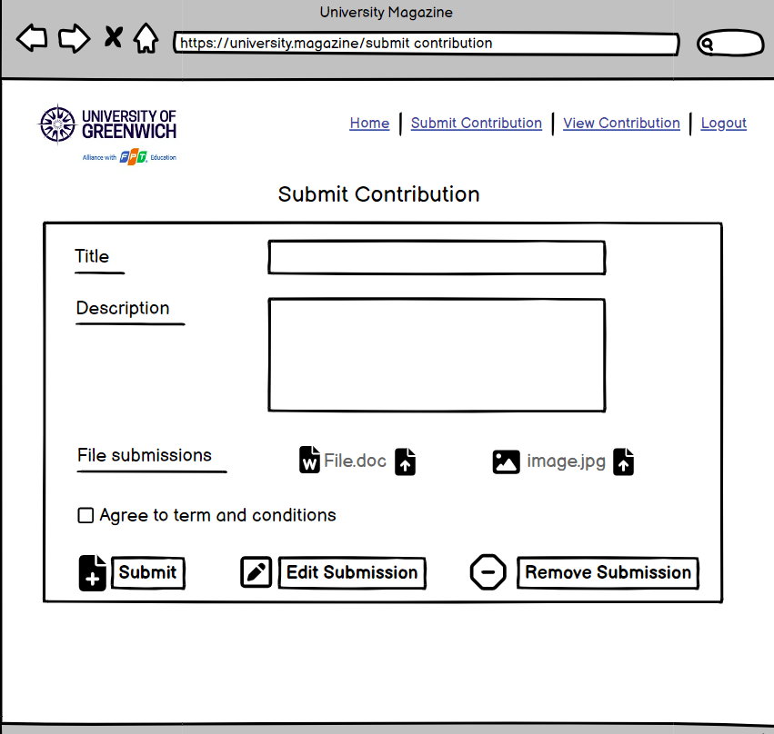

Testing

Test plan

Test cases

|  |  |  |  |  |
| --- | --- | --- | --- | --- |
| ID | Description | Practice | Data | Results |
| 1 | Check for successful login | Run the browser | No | OK |
| 2 | Check List Users | Login Admin account | Username and password are Admin | OK |
| 3 | Check Statistic | Login Manager account | Layout statistic | OK |
| 4 | Contribution from student | Login student account | Submit the contributions | OK |
| 5 | Status and Feedback | Login coordinator account | View contributions from student and feedback | No |

Test logs

|  |  |  |  |  |
| --- | --- | --- | --- | --- |
| ID | Test cases | Status | Time practice | Results |
| 1 | Check for successful login | Pass | 2024-03-01 | OK |
| 2 | Check List Users | Pass | 2024-03-05 | OK |
| 3 | Check Statistic | Pass | 2024-04-15 | OK |
| 4 | Contribution from student | Pass | 2024-04-05 | OK |
| 5 | Status and Feedback | Not pass | 2024-04-20 | Unable to export data |

**Coding**

**Login and authorization function**

Login.cs

AccountController.cs

Login.cshtml

**Function CRUD in Faculty**

Faculty.cs

FacultyController.cs

Create.cshtml

Details.cshtml

Index.cshtml

Edit.cshtml

Delete.cshtml

**Function List Users**

User.cs

UserController.cs

Create.cshtml

Edit.cshtml

Delete.cshtml

Index.cshtml

**Function Statistic**

**Function Student Submission**

**Function View and Download ZIP file**

**Function Status and Comment**

**Evaluation**

Working

As the team's SCRUM master, I often have a positive approach in supporting other members when they encounter difficulties in their work, such as coming up with better ideas, solutions, or perhaps upcoming Schedule a meeting to find the right answer. On the other hand, I need to divide labor properly. Each team member has different skills, so I have to carefully choose which tasks are appropriate for each person as well as the time for each task. Furthermore, I had to complete the task on time and in addition to the criteria, I also included some features to improve the program.

Knowledge

As a SCRUM master, I have to define the correct SCRUM properties. This will increase the effectiveness of tactics such as improving the effectiveness of team meetings, gathering member opinions, assessing user needs and solving problems.

What to do and what not to do

As a SCRUM master and team leader, I discuss how members work; some members may make mistakes; In these cases, I have to collaborate with them, listen to their perspectives and come up with appropriate ideas and solutions. I am the liaison between team members, making sure everyone is doing the right thing and every job is completed on time. On the other hand, I try not to put pressure on the group, keep a positive mood, and contribute negatively to the group.

Judgment

Because I discovered that all SCRUM principles were inappropriate for our team, I chose to choose specific SCRUM qualities that were appropriate for our project. I selected Sprint Backlog, Product Backlog, Scheduling, and so forth. However, in this situation, I also tailor these characteristics to better suit my team. In the Scrum Daily property, for example, all team members must report on their work on a daily basis. Instead of holding a team meeting to provide reports, I chose to use Skype or Google Hangout; each meeting now lasts approximately 5 minutes, and members may participate remotely. Members will have more time to complete their jobs this way.

Test

I practiced my assignment in order to comprehend the requirements. When I evaluate a case, I must ask myself several questions and provide answers to each of those inquiries. I may identify my skills and limitations by taking the exam. When I'm confused about anything, I frequently seek suggestions and answers from other members who have more experience than me. By listening to their comments and implementing them to my work, I can ensure that everything I do is on track and achieves the desired results.

**Conclusion**

The end result our team achieved was a role-based web application that performed well and met the majority of requirements. Security is guaranteed using MVC ASP.NET. The application of professional layout design, such as Boostrap, allows the program to work on multiple platforms. Applying SCRUM techniques to application development greatly improves the development process and ensures that all tasks are completed on time. Testing throughout the development process saves time and reduces the possibility of errors. This project taught us a lot and it will be very beneficial in the future.